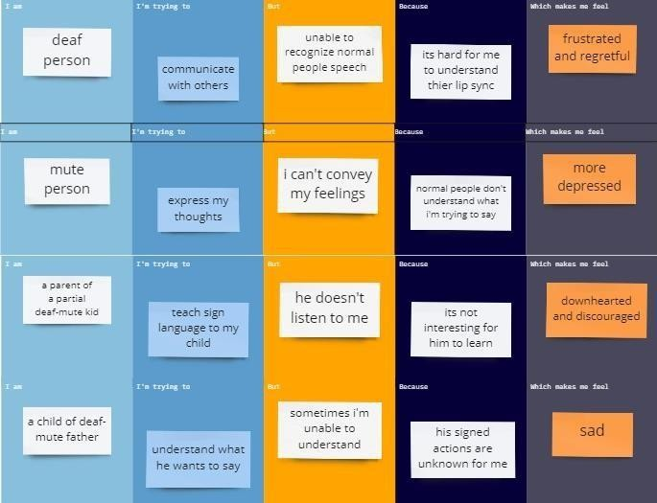IDEATION PHASE

Define the Problem Statement

|  |  |
| --- | --- |
| Date | 15 October 2022 |
| Team ID | PNT2022TMID26790 |
| Project Name | Real-Time Communication System Powered by AI for Specially Abled |

PROBLEM STATEMENT

|  |  |  |  |  |
| --- | --- | --- | --- | --- |
| **I am** | **I’m trying to** | **But** | **Because** | **Which makes me feel** |